MARCO POLO AWARD
for the creation of a joint CEE tourism product
for Chinese tourists

APPLICATION FORM
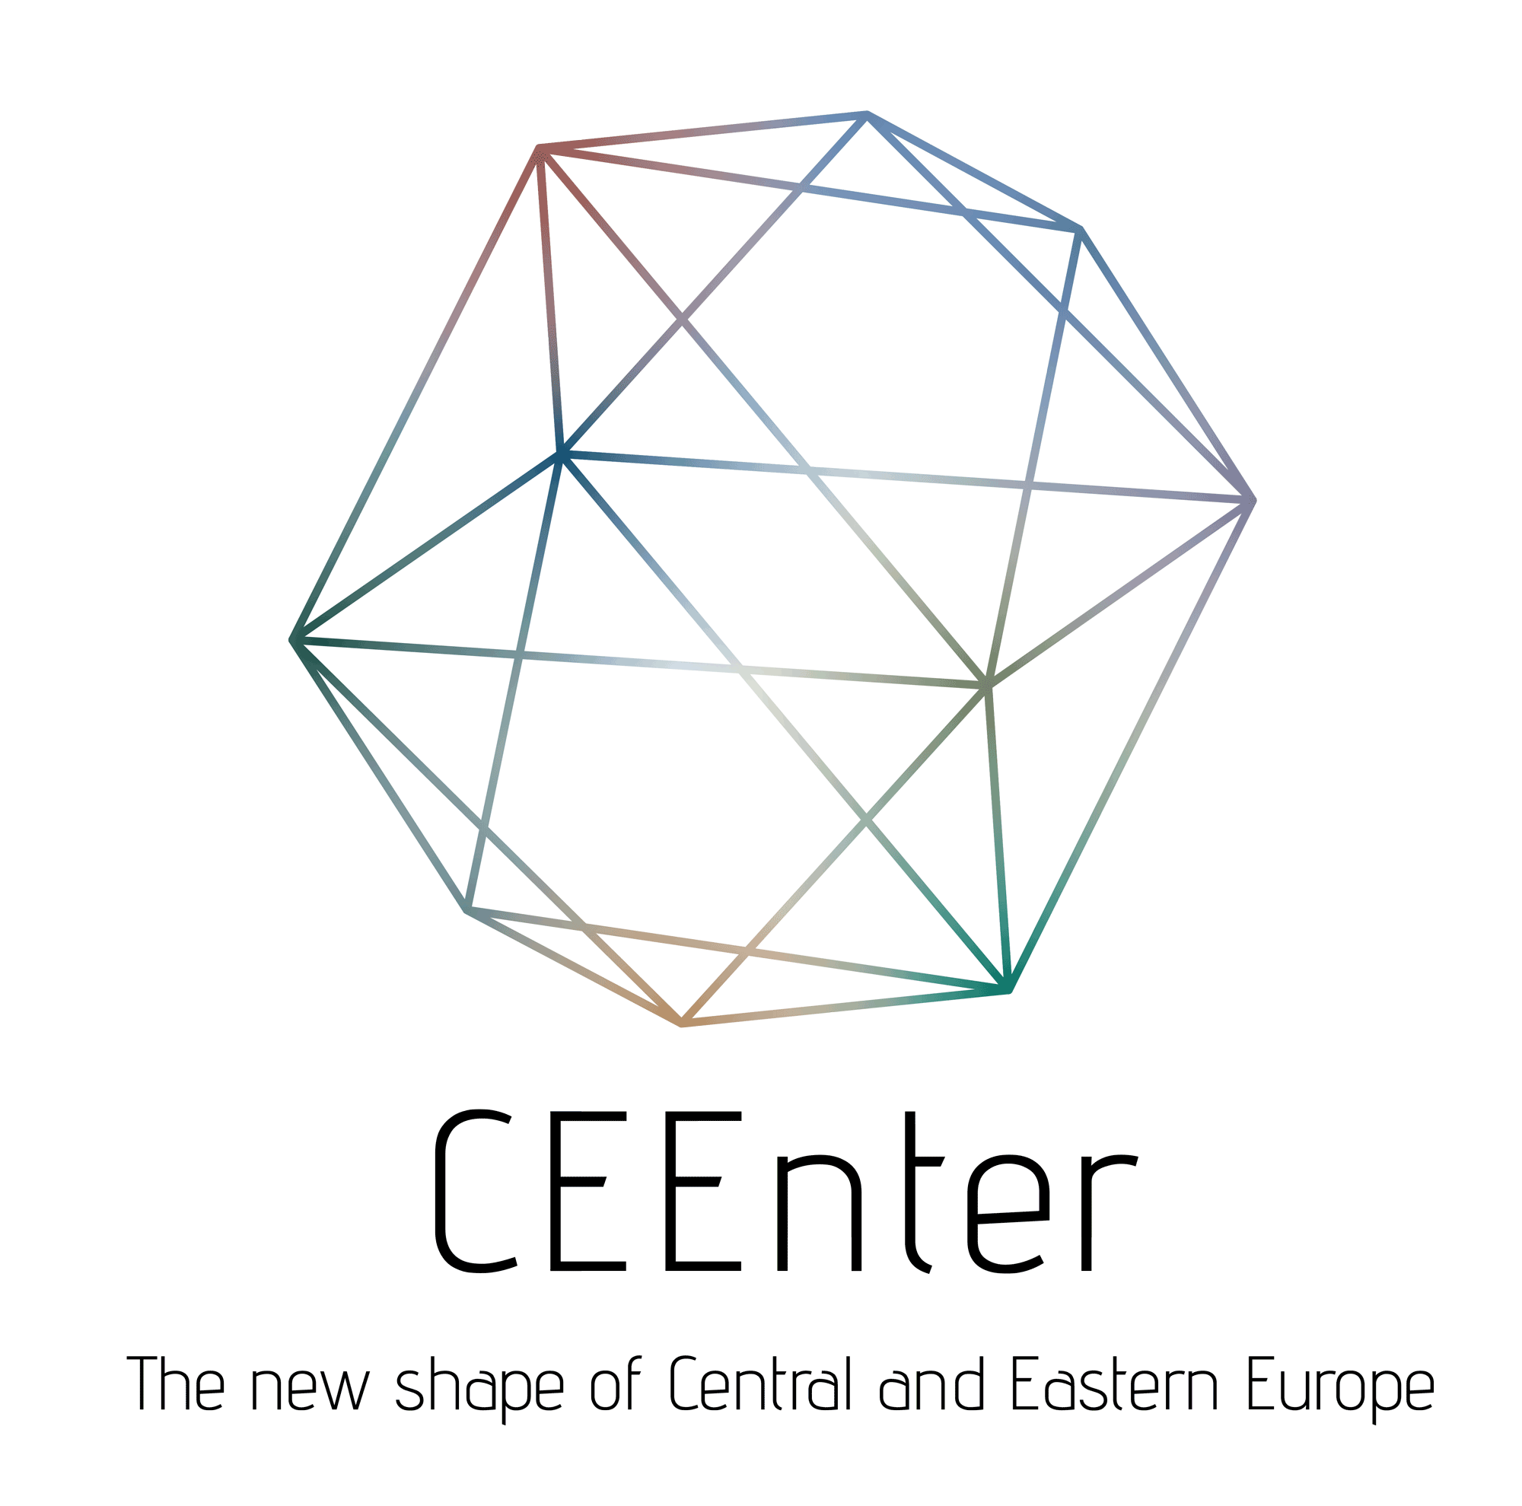
Please use this form to apply for the Marco Polo Award 2019.
Application Deadline: 31st May 2019
Send to e-mail tcc@mfa.gov.hu

Applicant
Address
website
website in Chinese (if applicable)
Contact data
name:
e-mail:
Phone:
Company profile (max 150 words)

Name and description of tourism product. Results achieved in 2018 (max 1200 words)
List of supplementary documents

Any other relevant information (optional)
Date, Place

